Information on Accommodation, Transportation and AUT Akoranga Carparking
ACCOMMODATION
Auckland CBD:
When searching for accommodation, please refer to the following streets and areas. These locations are near/centrally connected to Auckland’s public transport network, including buses, ferries, and trains.
- Albert Street
- Hobson Street
- Anzac Avenue
- Victoria Street – West
- Wellesley Street – East
- Queen Street – Lower to Midpoint
- Customs Street - East
- Britomart/Waitematā Station
- Aotea Square
Near AUT North Shore:
 | Approx Distance (Walk)
Takapuna Motor Lodge | ~ 0.9 km
Poenamo Hotel | ~ 1.0 km
Takapuna International Motor Lodge | ~ 1.05 km
Anzac Court Motel | ~ 1.21 km
Pupuke Manor Motel | ~ 1.01 km
The Spencer Hotel (Spencer on Byron) | ~ 1.38 km
Ocean Inn Motel | ~ 1.25 km
Carnmore Hotel, Takapuna | ~ 1.72 km
City of Sails Motel | ~ 1.69 km
Quest Takapuna | ~ 2.2 km

TRANSPORT IN AUCKLAND CBD and AUT AKORANGA (NORTH) CAMPUS
By Bus:
You may take the NX1 (via Lower Albert Street Bus Interchange) or the NX2 (via Wellesley Street East), both of which run every 10 minutes during the day, if your accommodation is in Auckland CBD. Alternatively, if your accommodation is located near AUT Akoranga (North) Campus, you can make use of the North Shore bus network. Plan your journey on the Auckland Transport website.
To pay for buses in Auckland, use a pre-loaded AT HOP card or a contactless payment method like a Visa, Mastercard, or American Express debit/credit card, or your digital wallet on a smart device. Information regarding AT HOP card can be found here: How to buy an AT HOP card
By Uber Ride:
Uber ride is available around Auckland for rides. You can book a ride through the Uber app which can be downloaded at the App Store for Apple devices (like iPhones) or Google Play for Android devices.
By Taxi:
You can book a taxi by calling major operators directly, such as Auckland Co-op Taxis (+64 9 300 3000), Alert Taxis (+64 9 309 2000), or Green Cabs (0508 447 336).

AUT AKORANGA (NORTH) CAMPUS CARPARKS
There is free parking available on nearby streets, although please make sure to check the time restrictions.

There is limited, on-site paid parking including mobility spaces at the North Campus – use the UbiPark app or the meter to pay: Use Carparks 2 and 7 for casual parking.

We recommend using Carpark 2, as it is the closest to the AZ and AF buildings, where the symposium will be held.
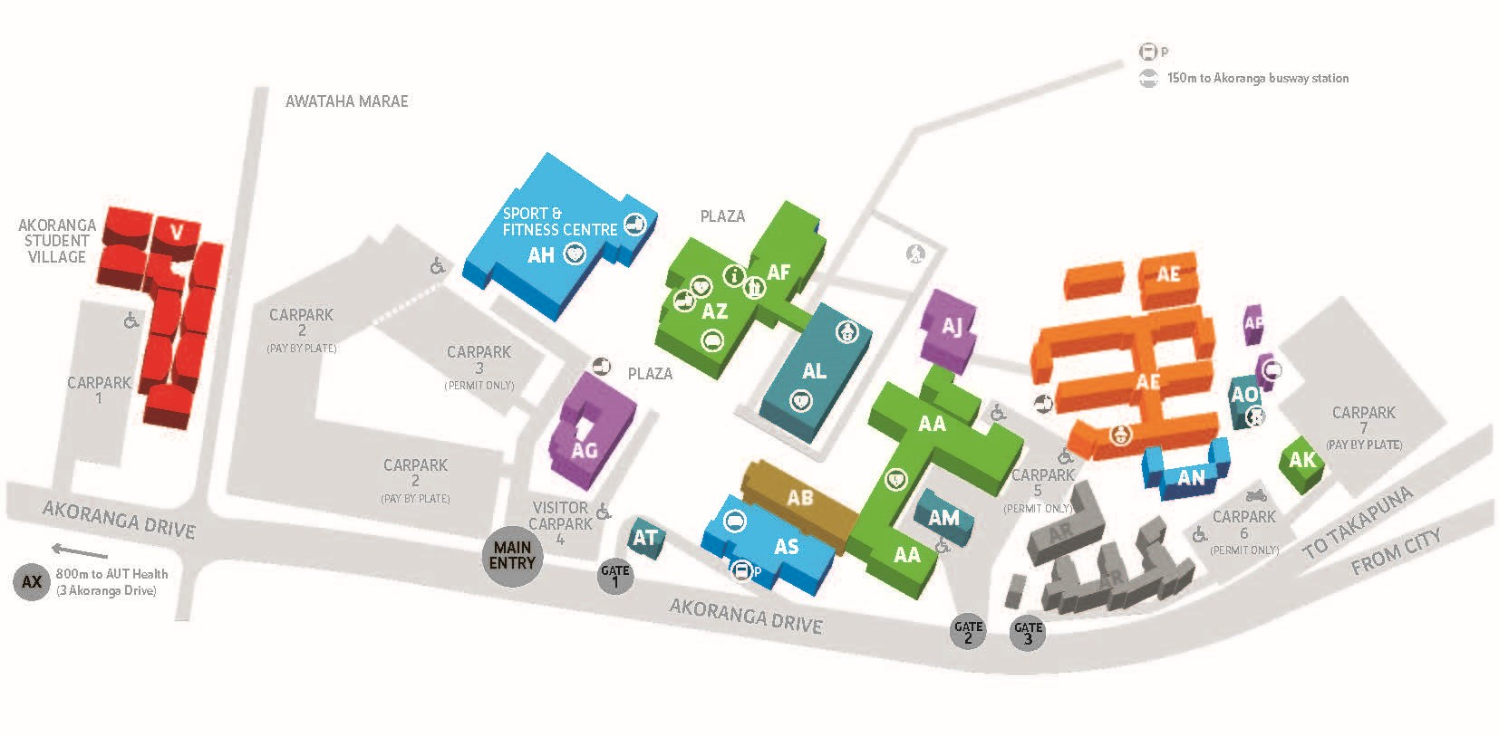
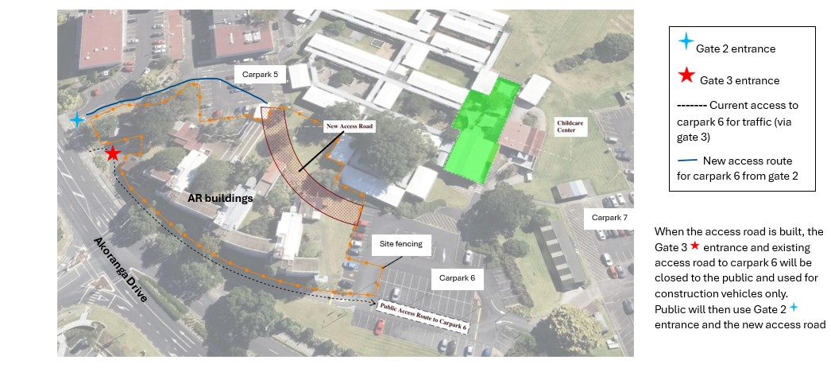
Entrance to Carpark 2
GATE 2: Entrance to Carpark 7. See instruction below for new access road to carpark 7 via Carparks 5 and 6 (both staff only carpark).

